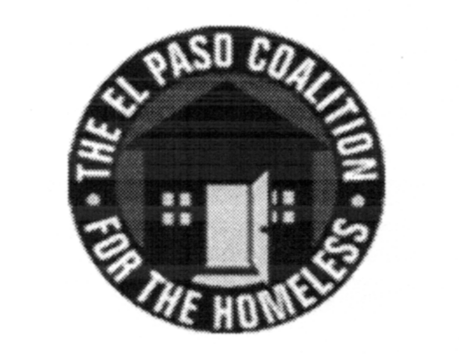
EL PASO COALITION for the HOMELESS
GENERAL MEMBERSHIP
January 11, 2018
El Paso Center for Children, 2200 N. Stevens St. 79930

Call to Order- The meeting was called to order by Executive Director Carol Bohle at 9:05 a.m.

Welcome and Introductions- Carol welcomed the members and thanked the El Paso Center for Children for hosting. Art Jaime, COO, provided an overview of the services provided by the Center. Members in attendance from various agencies introduced themselves.

Approval of Minutes –A motion for approval of the EPCH General Membership Meeting minutes from December 14, 2017 was made by Olivia Narvaez and seconded by Michael Flores. The minutes were approved as presented.

EPCH Board of Directors Report – Michael Flores, President of the EPCH Board, welcomed the members in attendance, wishing them a Happy New Year and thanked them for being there. There was no report from the Board as the first Board meeting of the year was scheduled for the following week.

Planning Committee Report – Shadecie Walker, Chair of the Planning Committee, reviewed the date revisions to the Strategic Plan as recommended by the subcommittees for each strategic objective. These new dates would replace the original target dates previously approved. Shadecie made a motion to accept the new target dates. Robin Rollins seconded. The motion was approved. Shadecie made a motion to allow the Planning Committee to change target dates as necessary, based on recommendations by the subcommittees. Olivia Narvaez seconded. The motion was approved.

Involving Local and State Departments in Addressing Homelessness – Jorge Contreras and Leslie Canada shared their experience on successful approaches in dealing with the El Paso Police Department and Adult Protective Services regarding homeless clients.

Agency Announcements – Agency announcements were made.

Adjourn – The meeting was adjourned to Strategic Plan subcommittees at 10:05 a.m.

