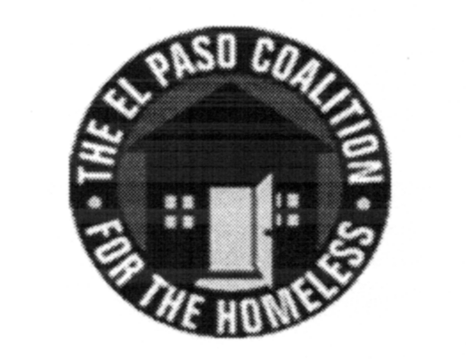
EL PASO COALITION for the HOMELESS
GENERAL MEMBERSHIP
February 8, 2018
Centro San Vicente Family Health, 8061 Alameda

Call to Order- The meeting was called to order by Shadecie Walker, YWCA at 9:06 a.m.

Welcome and Introductions- Shadecie welcomed the members and thanked Centro San Vicente for hosting. Members in attendance from various agencies introduced themselves.

Approval of Minutes –A motion for approval of the EPCH General Membership Meeting minutes from January 11, 2018 was made by Olivia Narvaez and seconded by Michael Flores. The minutes were approved as presented.

EPCH Board of Directors Report – Michael Flores, President of the EPCH Board, welcomed the members in attendance. Michael Flores provided an overview of EPCH Board discussions.

Planning Committee Report – Shadecie Walker, Chair of the Planning Committee, did not provide a report, because the Planning Committee was to meet the following week.

Q&A session with Everett Saucedo – Everett Saucedo provided a detailed overview of laws regarding Service Animals and Emotional Support Animals.

Recidivism – Camille Castillo provided members a hand out for the recidivism rate for 2015-2016 as per the System Performance Measures.

Agency Announcements – Agency announcements were made.

Adjourn – The meeting was adjourned to Strategic Plan subcommittees at 10:05 a.m.

