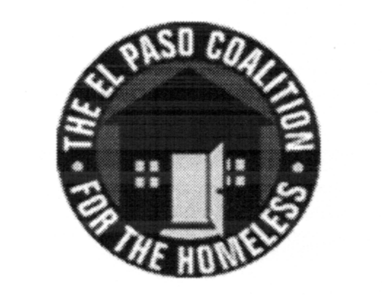
EL PASO COALITION for the HOMELESS
GENERAL MEMBERSHIP
November 27, 2018
El Paso County Community Services, 6314 Delta

Call to Order - The meeting was called to order by Executive Director Carol Bohle at 9:10 a.m.

Welcome and Introductions - Carol welcomed the members and thanked the County for hosting. Yvette Gonzales, Manager of the County’s General Assistance Department, provided an overview of the services provided by the County as well as an overview of the CE process. Members in attendance from various agencies introduced themselves.

Approval of Minutes – Minutes were not submitted for approval at this meeting.

CoC Board Report – There was no report from the CoC Board at this meeting.

EPCH Board Report – There was no report from the EPCH Board at this meeting.
Nominating Committee - Carol informed the group that this was the Coalition’s Annual Meeting held each year for the purpose of electing directors to the board. She introduced Ben Bass as a member of the EPCH Board’s Nominating Committee to present the candidates being recommended for board service. On behalf of the Nominating Committee, comprised of Bill Schlesinger, Susana Reza and Ben Bass, Ben moved to accept the following candidates for election to the El Paso Coalition for the Homeless Board of Directors for three-year terms beginning immediately and through November 2021: Rafael Elizondo, Everett Saucedo and Denise Pacillas. The motion carried.

Coalition Membership – Everett Saucedo, Membership Committee Chair, moved to accept Gilbert Marquez into membership, seconded by Art Jaime. The motion carried.

Addiction Campuses – Victoria Hawkins, Treatment Specialist, shared with the group the services provided by Addiction Campuses in El Paso.

Agency Announcements – Agency announcements were made.

Adjourn – A motion was made by Diana Duran to adjourn to Strategic Plan subcommittees at 9:50 a.m.

