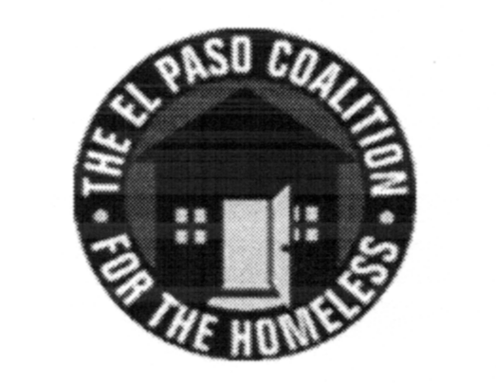
EL PASO COALITION for the HOMELESS
GENERAL MEMBERSHIP
February 14, 2019
Centro San Vicente, 8061 Alameda

Call to Order- The meeting was called to order by Executive Director Carol Bohle at 9:00 a.m.

Welcome and Introductions- Carol welcomed the members and thanked Centro San Vicente for hosting. Esther Avina provided an overview of the services provided by the organization. Members in attendance from various agencies introduced themselves.

Approval of Minutes – A motion for approval of the EPCH General Membership Meeting minutes from January 10, 2019 was made by Teresita Parra and seconded by Marta Mena. The minutes were approved as presented.

CoC Board Report – Bill Sparks, CoC Board of Directors, shared with the membership items discussed at the January CoC Board meeting including the board’s work on the El Paso CoC Governance Charter. CoC Board meetings are held at 4:00 p.m. on the second Thursday of each month.

EPCH Board Report – There was no EPCH Board meeting in January 2019 so there was no report. Meetings are held at 11:30 on the third Wednesday of each month.

EPCH Planning Committee – Shadecie Walker, Chair of the Planning Committee, reiterated that participation on Strategic Plan subcommittees was needed. Planning Committee meetings are held the second Tuesday of each month at 9:00 a.m. at TRLA.

American GI Forum – An overview of AGIF programs was provided by the director, the outreach coordinator and a case worker. Eligibility was reviewed for their programs and follow up meetings/trainings were discussed to ensure all providers were informed of the different eligibility requirements for housing, prevention and employment.

Coordinated Entry System, Yvette Gonzalez – Yvette continued to update members on the CE process, discussing what is working and what needs to be addressed. All feedback on CE will be submitted to the Coordinated Assessment Oversight Committee for consideration.

Agency Announcements – Agency announcements were made.

Adjourn – A motion was made to adjourn 10:20 a.m.

