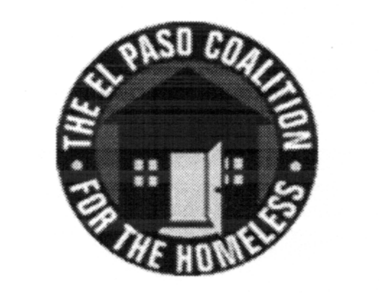
EL PASO COALITION for the HOMELESS
GENERAL MEMBERSHIP
March 14, 2019
YWCA TLC, 3700 Altura

Call to Order- The meeting was called to order by Executive Director Carol Bohle at 9:05 a.m.

Welcome and Introductions- Carol welcomed the members and thanked the YWCA TLC for hosting. Sierra Ulibarri provided an overview of the services provided by the organization. Members in attendance from various agencies introduced themselves.

Approval of Minutes – A motion for approval of the EPCH General Membership Meeting minutes from February 14, 2019 was made by Jane Leal and seconded by Yvette Gonzales. All approved.

CoC Board Report – There was no report from the CoC Board of Directors. CoC Board meetings are held at 4:00 p.m. on the second Thursday of each month.

EPCH Board Report – Ben Bass, Vice President of the EPCH Board, provided an update from the February 21, 2019 board meeting. Mr. Bass presented the following revisions to the EPCH Bylaws:
1) Request to allow for meetings of the Board, Advisory Board and Board-designated committees to be held by electronic means;
2) Designation of members of the Board, Advisory Board and Board-designation committees attending by electronic means as “present in person” for purposes of quorum;
3) Requirement for Board of Directors regular meeting minutes to be made available at the Annual Membership Meeting of the corporation rather than General Membership meetings.
Art Jaime moved to approve the revisions. Connie Jimenez seconded the motion. The motion carried.

EPCH Planning Committee – Shadecie Walker, Chair of the Planning Committee, reiterated that participation on Strategic Plan subcommittees was needed. Planning Committee meetings are held the second Tuesday of each month at 9:00 a.m. at TRLA.

Project Vida, Chris Bailey – An overview was given on the new SAMSHA grant which provides long term services and detox for those with alcohol and substance abuse issues.

2020 Census, Roque Aguon – A presentation was provided, followed by discussion, regarding the upcoming census and survey. Additional presentations will be made during the upcoming year.

Coordinated Entry System, Yvette Gonzalez – Yvette continued to update members on the CE process. All feedback on CE will be submitted to the Coordinated Assessment Oversight Committee for consideration.

Agency Announcements – Agency announcements were made.

Adjourn – A motion was made to adjourn 10:30 a.m. All approved.

