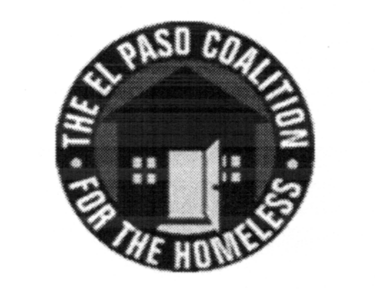
EL PASO COALITION for the HOMELESS
GENERAL MEMBERSHIP
January 9, 2020
El Paso Center for Children, 2200 N. Stevens St.

Call to Order- The meeting was called to order by Executive Director Carol Bohle at 9:05 a.m.

Welcome and Introductions- Carol welcomed the members and thanked El Paso Center for Children for hosting. Josue Lachica, Division Director for Youth Outreach & Housing, gave an overview of its programs and services. Members in attendance from various agencies introduced themselves.

Approval of Minutes – A motion for approval of the EPCH General Membership Meeting minutes from December 12, 2019 was made by Marta Mena and seconded by Justin Rotti. All approved.

CoC Board Report – Bill Sparks, CoC Board member, provided an update from the December CoC Board meeting.

EPCH Planning Committee – Shadecie Walker, Planning Committee chair, indicated that the committee would be discussing priority populations at the upcoming meeting and invited the membership to attend and join in the discussion. Planning Committee meetings are held on the second Tuesday of each month at 9:00 a.m. at TRLA.

Coordinated Entry – Camille Castillo, Project Director for the Coalition and interim chair for the Coordinated Assessment Oversight Committee, facilitated the monthly conversation regarding the local Coordinated Entry system. There were comments regarding calls and texts of referrals in addition to the current email process.

Housing Counselor Certification Rule – Camille reviewed the new rule, who it targets and the implementation deadline of August 1, 2020. The rule is not applicable to most programs, however, there was enough confusion that it needed to be clarified.

Self-Certification Households – Camille reviewed the percentage of clients self-certifying their homeless status and recommended new questions to assist in the verification process. Self-certification should be a last resort for homelessness verification.

Point-in-Time – Camille went over the process for the 2020 Point in Time count and survey, reminding everyone that the Planning Committee recommended a street count and that volunteers were needed. January 15 was the deadline to sign up online at the Coalition’s website. Training on the Counting US app for both unsheltered and shelter would be scheduled as soon as possible after the deadline. The count is scheduled statewide for January 23, 2020.

Agency Announcements – Agency announcements were made including an invitation from Sierra Ulibarri, Chair of the Performance and Benchmarks Committee, for their January 21, 2020 meeting at the Coalition offices.

Adjourn – A motion was made to adjourn 10:05 a.m. All approved.

