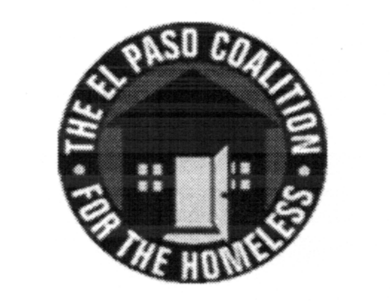
EL PASO COALITION for the HOMELESS
GENERAL MEMBERSHIP
June 11, 2020
Via Zoom

Call to Order- The meeting was called to order by Executive Director Carol Bohle at 9:03 a.m.

Welcome and Introductions- Carol welcomed the members for attending and called on each one to introduce themselves.

Approval of Minutes – A motion for approval of the EPCH General Membership Meeting minutes from March 13, 2020 was made by Martha Anchondo and seconded by Mike Gorley. All approved.

CoC Board Report – Ben Miranda, CoC Board Member, indicated that a CoC Board meeting would be taking place later the same day. He thanked the agency representatives and reiterated the CoC Board’s support for each program during the crisis.

EPCH Board Report – Everett Saucedo, EPCH Board member, reviewed the last two EPCH Board meetings that took place on February 19 and May 20, 2020. The Board reviewed and approved changes to the agency’s Bylaws that will be distributed at a later date for approval by the membership. These changes are recommended primarily to conform the Bylaws to the new quarterly meeting schedule approved by the membership in October 2019. The Board received an update on activities performed to date related to the coronavirus pandemic and its impact on homeless programs

EPCH Planning Committee – Shadecie Walker, Planning Committee chair, reviewed the items discussed as the June Planning meeting including the hospital discharge issues arising from the crisis as well as the need for transportation. Planning Committee meetings are held on the second Tuesday of each month at 9:00 a.m. via Zoom and all are encouraged to attend.

Economic Impact Payments for Americans Experiencing Homeless – The topic was presented for discussion and a work group was formed to develop practices on addressing these payments. The following volunteered to serve on this work group: Martha Anchondo (TSA), Josue Lachica (EPCC), Veronica Noriega (EHN), Everett Saucedo (TRLA), Camille Castillo (EPCH), Jose Orozco (AGIF), Adan Dominguez (Recovery Alliance) and Gary Gray (EPCH for HMIS System alerts).

How are WE doing? – Members provided updates regarding their programs and how the pandemic is affecting operations.

Agency Announcements – Agency announcements were made.

Adjourn – A motion was made to adjourn 10:15 a.m. All approved.

