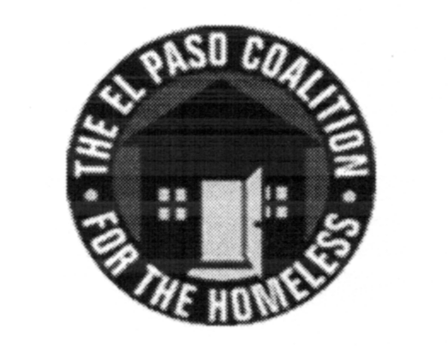
EL PASO COALITION for the HOMELESS
GENERAL MEMBERSHIP
March 8, 2018
YWCA TLC, 3700 Altura

Call to Order- The meeting was called to order by Executive Director Carol Bohle at 9:05 a.m.

Welcome and Introductions- Carol welcomed the members and thanked the YWCA TLC for hosting. Zuleiva Salinas and Teresa Laurenzana-Romero provided an overview of the services provided by the program. Members in attendance from various agencies introduced themselves.

Approval of Minutes – A motion for approval of the EPCH General Membership Meeting minutes from February 8, 2018 was made by Victor Hernandez and seconded by Michael Flores. The minutes were approved as presented.

Membership Committee – Everett Saucedo, Chair of the Membership Committee, announced that there was a new member request to be considered. The prospective new member wasn’t in attendance so the discussion and vote were tabled.

CoC Board Report – Camille Castillo, HUD Project Coordinator and liaison to the CoC Board, provided an update of the most recent CoC Board meeting. She announced that CoC Board meetings were held on the second Thursday of each month at 4:00 p.m. at the Diocesan Migrant & Refugee Services, Inc., 2400A E. Yandell.

EPCH Planning Committee – Shadecie Walker, Chair of the Planning Committee, reminded the group to attend the Planning Committee scheduled for the following Tuesday at 9:00 a.m.

UTEP CARE Program – A presentation was made by the UTEP Center for Advocacy Resources and Education on the MAPS (Miners Advocacy & Prevention Services) program, offering free and confidential services to any UTEP student, and their support system, who has been a victim of a crime.

Coffee with Leslie Session – Leslie Canada, Programs Analyst, reviewed quarterly performance for all Emergency and Transitional Shelters using HUD’s System Performance Measures, comparing programs to community-established benchmarks as a group and individually.

Performance Committee – Camille provided the baseline System Performance Measures report as submitted to HUD in 2017, which all future performance is measured against. Based on the CoC’s approved Community Performance Plan, a committee was formed to evaluate performance measures and make recommendations for improvement. The following members volunteered to serve on this committee: Connie Jimenez, City of El Paso (Cynthia Gonzales will be her backup); Teresa Laurenzana-Romero, YWCA (Zuleiva Salinas will be her backup); Darrell Mond, El Paso Veteran & Riders Association; Dorothy Truax, Reynolds House; Veronica Noriega, Emergence Health Network; Josue Lachica, El Paso Center for Children; Luis Carlos Terrazas, El Paso Human Services.
Agency Announcements – Agency announcements were made.

Adjourn – The meeting was adjourned to Strategic Plan subcommittees at 10:35 a.m.

