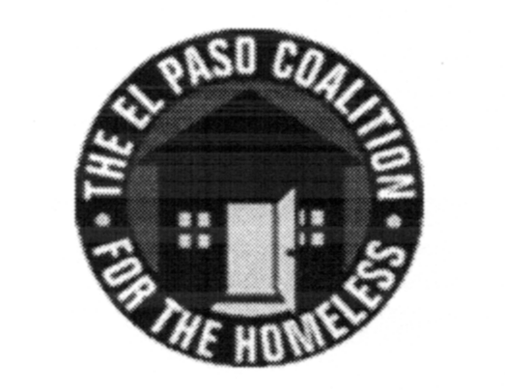
EL PASO COALITION for the HOMELESS
GENERAL MEMBERSHIP
May 10, 2018
The Salvation Army, 4300 E. Paisano

Call to Order- The meeting was called to order by Executive Director Carol Bohle at 9:05 a.m.

Welcome and Introductions- Carol welcomed the members and thanked The Salvation Army for hosting. Carol World provided an overview of the services provided by the organization. Members in attendance from various agencies introduced themselves.

Approval of Minutes – A motion for approval of the EPCH General Membership Meeting minutes from April 12, 2018 was made by Olivia Narvaez and seconded by Susana Reza. The minutes were approved as presented.

EPCH Board Report/Membership Committee – Everett Saucedo, EPCH Board member, reviewed the items discussed at the Board’s April meeting including the ratification of SBNG for the 2017 audit and approval for staff to attend a conference in Austin. The EPCH and CoC Boards are preparing for a joint meeting to discuss roles and responsibilities. The membership committee report was tabled.

CoC Board Report – Camille Castillo, as liaison to the CoC Board, provided an update of the most recent CoC Board meeting. The CoC Board is reviewing scoring tools for the upcoming CoC Program competition and has selected new members. Meetings are held on the second Thursday of each month at 4:00 p.m. at the Diocesan Migrant & Refugee Services, Inc., 2400A E. Yandell.

EPCH Planning Committee – Shadecie Walker, Chair of the Planning Committee, shared with the group the topics discussed at the Planning Committee meeting, particularly a discussion of a potential “stand down” for the homeless similar to the annual event for veterans. Meetings are held the second Tuesday of each month at 9:00 a.m. at TRLA, 1331 Texas Ave.

Coffee with Leslie Session – System Performance Measures - Leslie Canada, Programs Analyst, reviewed annual performance reporting mandated under federal regulations for homeless assistance programs. She reviewed specific metrics for 2017 performance that will be submitted at the end of the month reflecting the progress made by the El Paso CoC in meeting federal goals under the HEARTH Act.

Housing First – Camille Castillo, Grant Planner and HUD Project Coordinator, presented additional results from the November 2017 survey on Housing First practices in the El Paso CoC. A discussion ensued regarding documentation requirements which will be addressed specifically with relevant entities.

Agency Announcements – Agency announcements were made.

Adjourn – A motion by Olivia, seconded by Susana, was made and approved to adjourn to Strategic Plan subcommittees at 9:55 a.m.

