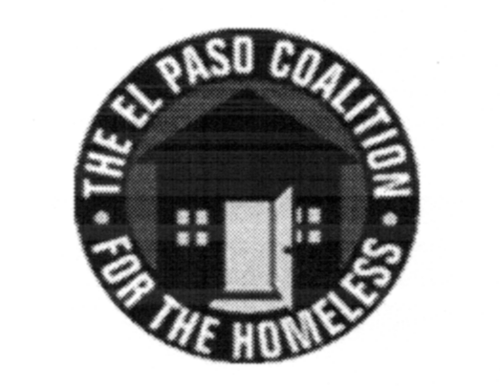
EL PASO COALITION for the HOMELESS
GENERAL MEMBERSHIP
September 12, 2019
Rescue Mission, 221 N. Lee

Call to Order- The meeting was called to order by Executive Director Carol Bohle at 9:05 a.m.

Welcome and Introductions- Carol welcomed the members and thanked the Rescue Mission for hosting. Rescue Mission CEO Blake Barrow gave an overview of its programs and services. Members in attendance from various agencies introduced themselves.

Approval of Minutes – A motion for approval of the EPCH General Membership Meeting minutes from July 11, 2019 was made by Martha Mena and seconded by Connie Jimenez. All approved.

Coalition Board Report – Ben Bass, Vice President of the EPCH Board of Directors, provided an update from August 21, 2019 EPCH board meeting including the presentation by SBNG of the agency audit for 2018. The agency once again received an unmodified opinion. Ben made the following motion:

On behalf of the El Paso Coalition for the Homeless Board for Directors, I move that the Bylaws be amended under ARTICLE IV: BOARD OF DIRECTORS, Section 8: Regular Meetings to read: The Board of Directors shall hold a minimum of four (4) regular meetings each year, the day and time to set by the President, with the approval of the Board of Directors. Blake seconded the motion. All approved.

This amendment reduces the number of required meetings from six (6) to four (4) for the EPCH Board of Directors. In compliance with the Bylaws, the amendment was emailed to the membership on September 10, 2019.

CoC Board Report – Bill Sparks, CoC Board member, reviewed the activities from the August 22, 2019 CoC Board meeting and thanked the members for their efforts to reduce homelessness in El Paso.

EPCH Planning Committee – Planning Committee Chair, Shadecie Walker, shared that the September meeting had been canceled and invited the members to attend the upcoming Planning Committee meeting to be held on Tuesday, October 8, 2019 at 9:00 a.m. at TRLA.

Coffee with Ashley – Ashley Lemell, Resource Administrator for EPCH, conducted an interactive presentation on Building Strong Collaborations among housing and services. Items discussed were a Resource Inventory, Identifying gaps, advocacy to address gaps, being consumer friendly.

Agency Announcements – Agency announcements were made.

Adjourn – A motion was made to adjourn 9:55 a.m. All approved.

