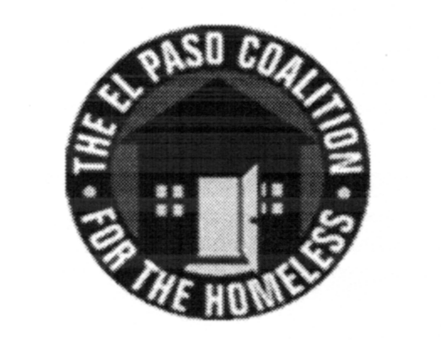
EL PASO COALITION for the HOMELESS
GENERAL MEMBERSHIP
December 12, 2019
El Paso Human Services, P.R.I.D.E. Center, 820 Montana

Call to Order- The meeting was called to order by Executive Director Carol Bohle at 9:05 a.m.

Welcome and Introductions- Carol welcomed the members and thanked El Paso Human Services for hosting. Susana Reza, Executive Director, gave an overview of its programs and services. Members in attendance from various agencies introduced themselves.

Approval of Minutes – A motion for approval of the EPCH General Membership Meeting minutes from November 14, 2019 was made by Bill Sparks and seconded by Susana Reza. All approved.

CoC Board Report – Bill Sparks, CoC Board member, provided an update from the November CoC Board meeting. He reiterated that the CoC Board leans on the EPCH and the EPCH, in turn, relies on providers in addressing homeless issues in our community.

EPCH Board Report – Adan Dominguez, EPCH Board member, gave the report from the quarterly EPCH Board meeting including the results of officer elections: President – Bill Schlesinger (to serve a second term), Vice President – Denise Pacillas, Secretary – Rafael Elizondo and Treasurer – Adam Lozoya. Susana Reza, Adam Lozoya and Everett Saucedo were elected to serve as the Nominating Committee and Adan Dominguez was elected as Membership Chair. The board approved Schmid, Broaddus, Nugent and Gano to serve as the auditor for the 2019 Financial Statements and Form 990. The next board meeting will be held February 19, 2020.

EPCH Planning Committee – Ashley Lemell, Resource Facilitator for the Coalition, provided an update from the December Planning Committee on behalf of chair, Shadecie Walker. Planning Committee meetings are held on the second Tuesday of each month at 9:00 a.m. at TRLA.

Coordinated Entry – EPCH staff facilitated a discussion focused on both CE concerns and positive feedback. Carlos Marquez was introduced as new General Assistance Manager responsible for management of CE at El Paso County.

Annual HMIS Recognition – Bill Sparks, with assistance from CoC Board member Ben Miranda, facilitated the recognitions for those programs that had outstanding HMIS Data Quality Performance for data entry timeliness. The winners were: Aliviane PATH in the category of Street Outreach, Winchester House and The Salvation Army in the categories of small and large Emergency Shelters, the Opportunity Center PSH in the category of Permanent Supportive Housing, Center Against Sexual and Family Violence in the categories of Rapid Rehousing and Transitional Housing, and a three-way tie in the category of Homelessness Prevention for La Posada ESG, Project Vida HHSP and American GI Forum SSVF.

Tamales with Ashley – Ashley Lemell facilitated an interactive discussion regarding Harm Reduction.

Agency Announcements – Agency announcements were made.

Adjourn – A motion was made to adjourn 10:30 a.m. All approved.

